**Simulation and Analysis of Puregold Junior Don Placido Campos Avenue Branch**

Fauni, Allyza Mae

[*allyzamae.fauni@tup.edu.ph*](mailto:allyzamae.fauni@tup.edu.ph)

*Bachelor of Science in Computer Science*

*Technological University of the Philippines Manila*

Owera, Marvin

[*marvin.owera@tup.edu.ph*](mailto:marvin.owera@tup.edu.ph)

*Bachelor of Science in Computer Science*

*Technological University of the Philippines Manila*

Rocero, Ma. Hazel

[*mahazel.rocero@tup.edu.ph*](mailto:mahazel.rocero@tup.edu.ph)

*Bachelor of Science in Computer Science*

*Technological University of the Philippines Manila*

Sallador, Luzmarie

[*luzmarie.sallador@tup.edu.ph*](mailto:luzmarie.sallador@tup.edu.ph)

*Bachelor of Science in Computer Science*

*Technological University of the Philippines Manila*

***Abstract – This study presents a simulation and analysis of Puregold Junior Don Placido Campos Avenue Branch. In order to help lessen the amount of time spent inside the supermarket store, analyzation of the mentioned branch was accomplished using a discrete event simulation model in AnyLogic Software. A discrete event simulation model is a method used to represent any real-world system that can be turned into a set of logically separate process that autonomously progress through time. Thereafter simulating the model, it has found that customers spent around 15 minutes inside the supermarket. But since the selected supermarket was way smaller compared to other supermarket, it is suggested to bring a list of items to buy in order to lessen the time that each customer spend inside.***

***Keywords: AnyLogic Software, Simulation and Analysis, Supermarket***

1. **INTRODUCTION**

One of the common things that a household does is to shop or buy their fundamentals and other necessities needed at some supermarket or grocery stores. Plenty of different supermarket stores were built not just in urban places but also in rural provinces. As of 2020, there is an overall total of 739 supermarkets in the Philippines [1]. Savemore Supermarket dominates the data with 207 store branches meanwhile, Puregold is third in the list with a total number of 101 store branches. The usual peak hours of supermarkets are from 4 pm until 6 pm since office hours usually end during that time. Typically, a customer consumes an hour to shop if it would only buy a week's number of items. The mere act of waiting in line at a checkout, a bus stop, or outside an event triggers certain brain response that have an impact on our mood and perception of the environment [2]. People don’t want to wait for a long time in a waiting or queue line because aside from it being exhausting, it also consumes time. Due to this, certain supermarkets like SM Supermarket built convenience stores that customers could easily access from their neighborhood.

The researchers have only found a few papers related to the study. Most studies recommend adding more cash desks and cashiers to solve the waiting time of the customers. In one related study, the researchers concluded that automatic cash desks can considerably shorten the lines for customers with few items to purchase [3]. However, since these customers typically make up a small portion of the total customers, switching one cash desk from regular to automatic will typically prolong lines and worsen the situation.

According to the researchers, [4] if 2 to 3 more cashiers are employed, customer wait times will be reduced by 88.23 percent. The average queue size will be reduced by 87.68%. The average use of the attendant is reduced by 5.17%.

This study aims to simulate and analyze Puregold Junior D. Placido Campos Branch. The study focused on the amount of time that the customer consumed inside the mentioned supermarket branch. On the last chapters of this study, the researchers will answer the question, “Is the simulation model created similarly to the real-world supermarket?”. After the analyzation and discussion of the results, the researchers will suggest a solution for the betterment of the said supermarket. The next chapters will discuss the methods used, results, discussion and conclusion of this study.

1. **CASE STUDY BACKGROUND AND SIMULATION METHOD**
2. *Case Study Background*

The selected supermarket branch for this study was open from 7:30 in the morning until 9 o'clock in the evening. The researchers observed the branch from 11 am in the morning until 3 pm in the afternoon. The data collected consists of the customers' time of arrival and exit, and some information such as the number of cash desks and employees present at that time. It has five cash desks, three of them accept cash-only payments while the remaining two are for automatic cash payments. The branch has different sections for meats, fish, vegetables & fruits, and dry grocery items. Puregold Junior D. Placido Campos branch is surrounded by bigger supermarkets, hence the reason why they have only a few customers every hour.

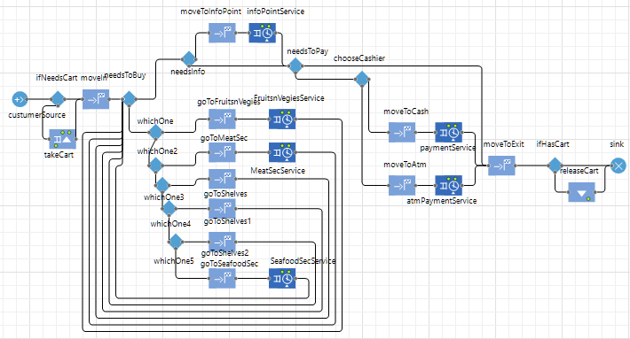

*Table 2.1 Data Collected from Observation*

The table above (*Table 2.1*) shows the data collected from observing the mentioned supermarket and was tallied and calculated the customers time spent inside the supermarket.



*Table 2.2 Computation of Data Collected*

The table above is the computation of the recent table. Those results will be used for validating the model and for the model as well. The researchers did not solve for the probability of the collected data as the software will helps us do it by using data analysis operators.

1. *Simulation Methodology*

The researchers used the software AnyLogic to simulate and analyze the data collected. In doing so, the researchers used the Discrete Event Simulation Method to simulate and model the selected supermarket branch. AnyLogic simulation models enable analysts, engineers, and managers to gain deeper insights and optimize complex systems and processes across a wide range of industry sectors, including logistics, manufacturing, transportation, aerospace, defense, and mining [5]. Before simulating the system in the software, the researchers created a flowchart to use as the base for the flow of the system. The flowchart contains the process of the customers movements in the supermarket based on the observation made by the researchers.

*Figure 2.1 Process Flowchart*

The figure above is the flowchart of the systems process. It was based on the customers decisions and movements inside the supermarket. Once the customer arrived in the supermarket, it would decide on what to buy and will move afterwards. After deciding and buying the items to buy, the customer will now decide for the payment method and will move forward to the exit.

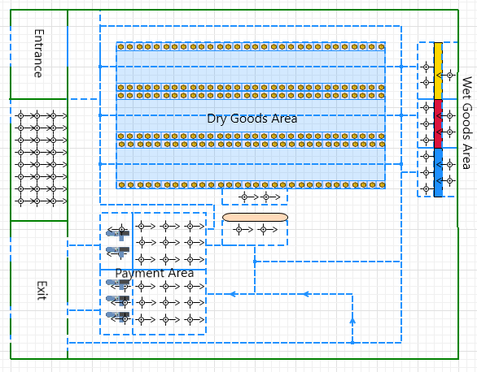 The next process to do is to design the simulation visual model similar to the supermarket, to match the look of the selected real-world supermarket.

*Figure 2.2 Puregold Simulation Visual Model*

The figure above is how the selected system looks like in real-word and is adapted and created in the simulation model. The placing of the areas is conceptualized based on the observation of the researchers.

Following the creation of the flowchart and visual models the next step is to create the agents that would move inside the model. Model Agents are main building blocks of AnyLogic model. Agent is a unit of model design that can have behavior, memory (history), timing, contacts, etc. As there are many different types of agents, it could be defined as many as needed in the model. In the model, agents’ behavior using parameters, variables, collections, functions, events, option lists and statecharts will be defined. [6]. The researchers used model agents to properly disseminate the process and flow of the model. By using agents, behaviors and some attributes will be defined and match to the model. Modifying and defining agents’ behaviors and attributes was done in the properties tab of each agent and libraries. Design of an agent typically starts with identifying its attributes, behavior, and interface with the external world. In case of large number of agents with dynamic connections (such as social networks) agents can communicate by calling functions [6]. The following list below are the agents used in the simulation model:

1. *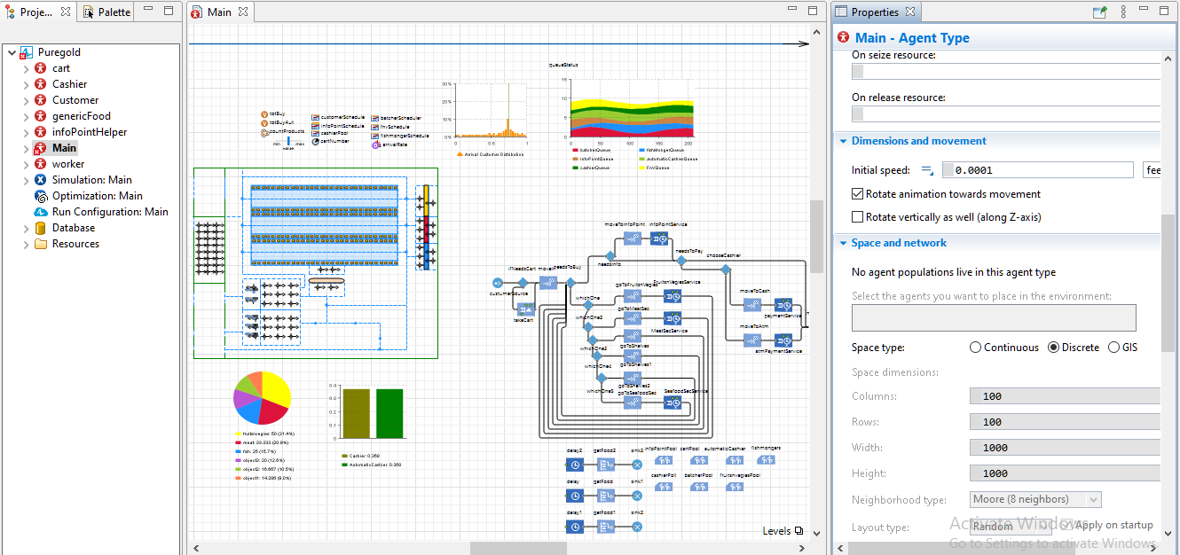Main* – This is the main and default agent type that the model will use as the executable agent. After creating a new model, main agent will be automatically created along with the experimental simulation. All the previously discussed steps and process are located and can be defined in this agent.

*Figure 2.3 Main Agent*

The figure above is the screenshot of the main agent of the simulation model of this study. As mentioned earlier, flowchart, visual design and data analysis of the model are established in this agent. And since this agent is created automatically once a new model was created, the model will use this agent to execute the simulation.

1. *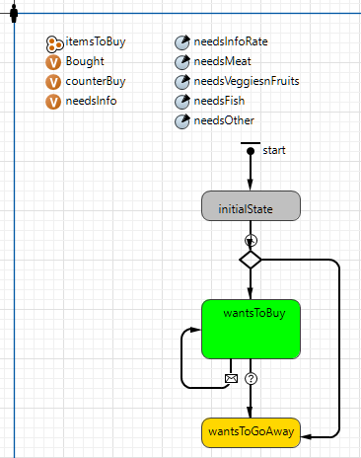Customer –* This agent moves around the system similarly to how it moves in real world. By doing it, the researchers defined a process flowchart on how the customer will move and decide inside the simulation model.

*Figure 2.4 Customer Agent*

Figure 2.4 shows the process flowchart, attributes and behavior of the customer. By using statecharts, the process flowchart was created. Like how the customer usually decides, the researchers arranged and modified it. Items that the customer would like to buy are defined in the initialState by using java programming language. The orange shapes and letters on the left side are the variables of the customer. On the other side, the clock-like shapes are the parameters wherein the possibility that the customers will pick it was defined.

1. *Cashier –* This agent type was defined to make the agent appear only when necessary in the simulation. Several cashiers are sometimes not present in their assigned cash desks for some valid reason, which is why the researchers created this agent to properly assign and schedule the movement and placement of the cashier inside the simulation model.
2. *Worker, InfoPointHelper, Cart, GenericFood –* This agent was defined as the worker assigned for the Wet Goods Area. And just like how the cashiers are sometimes not available, the researchers did the same for this agent.
3. **EXPERIMENTS AND RESULTS**
4. *Experiments*

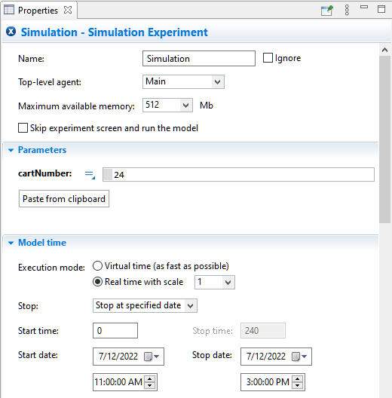When a new project is created, one experiment is created automatically. It’s a simulation experiment named Simulation. It runs model simulation with animation displayed and model debugging enabled [7]. Simulation Experiment presented in *Figure 3.1*sets the model time of the simulation. The researchers inserted the time that was observed. In this study, there are two experiments used in order to optimize and stabilize the simulation of the system. The other experiments used is the Optimization, it finds the optimal combination of parameters that results in the best possible solution. Using the optimization experiment you can observe system behavior under certain conditions, as well as improve system performance [7]. As seen in Figure 3.2, the researchers defined a parameter for the cart agent in order to make it move accordingly (once the customer was done using it, the cart will return to its original placement).

*Figure 3.1 Simulation Experiment Properties*

*Figure 3.2 Optimization Experiment Properties*

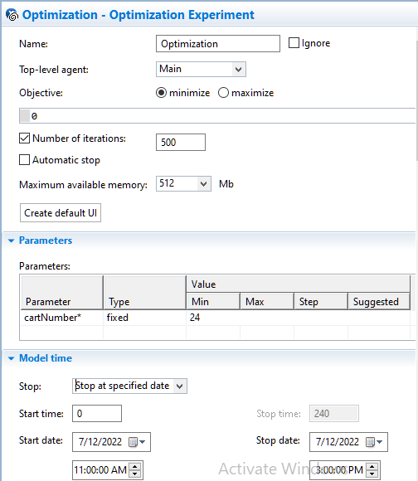

1. *Data Analysis*

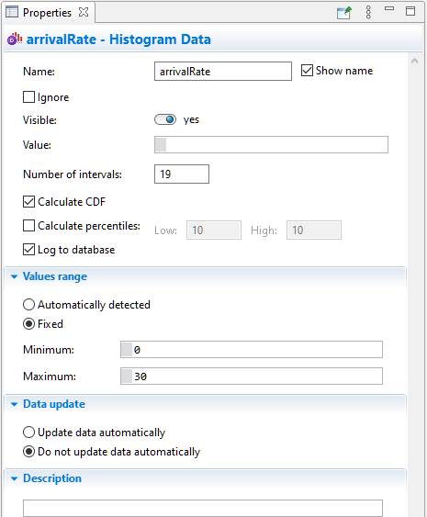The data analysis of the simulation model was also affixed inside the system to analyze the result. Histograms and Time Stack Charts are added to evaluate and study the result of the simulation. Figure 3.3 presented the histogram data properties for the arrivalRate of the customers in the model. In this data, the researchers defined the number of intervals at 19 based from the computed data collected. Values Range was also defined based on the maximum time spent of the customers inside the supermarket.

*Figure 3.3 ArrivalRate Histogram Data*

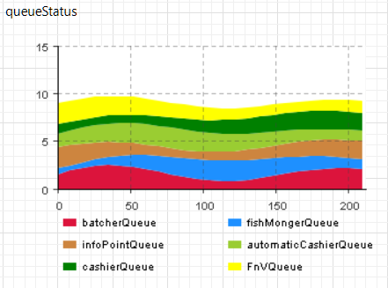Time Stack Chart presented in Figure 3.4 was also added and it consists of queueStatus data that was collected from the simulation process. Once the simulation run and queuing started to buildup, it would be visible in this chart.

*Figure 3.4 QueueStatus Time Stack Chart*

1. *Results*

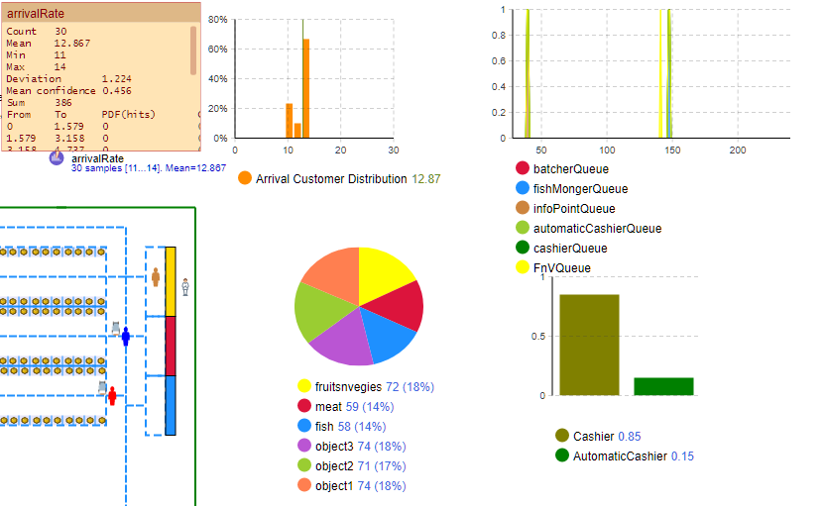After completing and building the simulation model, the researchers will now proceed on running the executable main agent of the model.

*Figure 3.5 Simulation Result*

The figure above is the simulation results of the simulation model. The Data Analysis showed the Customers Arrival Distribution, the QueueStatus on each area of the supermarket, the statistics of the items bought and the rate on which payment area do most customers preferred.

|  |  |  |  |
| --- | --- | --- | --- |
| ***Arrival Customer Distribution*** | | |  |
| ***Count*** | 30 |  |  |
| ***Mean*** | 12.867 |  |  |
| ***Min*** | 11 |  |  |
| ***Max*** | 14 |  |  |
| ***Deviation*** | 1.224 |  |  |
| ***Mean confidence*** | 0.456 |  |  |
| ***Sum*** | 386 |  |  |
| ***from*** | ***to*** | ***PDF*** | ***CDF*** |
| 0 | 1.578947368 | 0 | 0 |
| 1.578947368 | 3.157894737 | 0 | 0 |
| 3.157894737 | 4.736842105 | 0 | 0 |
| 4.736842105 | 6.315789474 | 0 | 0 |
| 6.315789474 | 7.894736842 | 0 | 0 |
| 7.894736842 | 9.473684211 | 0 | 0 |
| 9.473684211 | 11.05263158 | 0.233 | 0.233 |
| 11.05263158 | 12.63157895 | 0.1 | 0.333 |
| 12.63157895 | 14.21052632 | 0.667 | 1 |
| 14.21052632 | 15.78947368 | 0 | 1 |
| 15.78947368 | 17.36842105 | 0 | 1 |
| 17.36842105 | 18.94736842 | 0 | 1 |
| 18.94736842 | 20.52631579 | 0 | 1 |
| 20.52631579 | 22.10526316 | 0 | 1 |
| 22.10526316 | 23.68421053 | 0 | 1 |
| 23.68421053 | 25.26315789 | 0 | 1 |
| 25.26315789 | 26.84210526 | 0 | 1 |
| 26.84210526 | 28.42105263 | 0 | 1 |
| 28.42105263 | 30 | 0 | 1 |

*Table 3.1 Customer Arrival Rate Distribution*

The table above specified the probability distribution of the customers arrival rate. In this table, the total customers arrived in the system had a total of 30 with a mean of 12.867 and a sum of 386. The maximum time of the customers spent in the system is 14 minutes meanwhile the minimum is at 11 minutes. Using the histogram data operator in Analysis Library of AnyLogic, the Standard Deviation, Mean Confidence, Probability and Cumulative Distribution was automatically calculated with the support of proper affixing necessary operators.

1. *Verification and Validation*

Verification is the process of defining that a model implementation and its linked data correctly represent the researcher’s conceptual description and specifications [8]. The researcher’s main objective of this study is to simulate and analyze customers time spent inside the supermarket. And based on the results of the simulation model, the researchers could say that the model was built similar to how the system actually looks and works like.

Validation is the process of defining the degree to which a [simulation] model and its related data are an accurate representation of the real world from the perception of the planned uses of the model. In order to validate the model, the researcher used a Hypotheses Method wherein the following hypotheses will be tested:

The researchers will test if the simulation model results and the observed data are significant to each other using t-test with a significance level of 0.1.

$H_{0}$: There is no difference between the two sample data.

$H_{1}$: There is a difference between the two sample data.

$$t= \frac{{\bar{x}}^{1}- {\bar{x}}^{2}- ∆}{S_{p}*\sqrt{\frac{1}{n_{1}}+\frac{1}{n_{2}}}}$$

where sₚ is called pooled standard deviation, which can be computed by:

$$S_{p}=\sqrt{\frac{\left(n_{1}-1\right)s_{1}^{2}+\left(n_{2}-1\right)s_{2}^{2}}{n_{1}+n_{2}}}$$

* Δ is the mean difference postulated in H₀
* n₁ is the first sample size
* x̄₁ is the mean for the first sample
* s₁ is the standard deviation in the first sample
* n₂ is the second sample size
* x̄₂ is the mean for the second sample
* s₂ is the standard deviation in the second sample

$$S_{p}=\sqrt{\frac{\left(30-1\right)\frac{1.22}{3.52}+\left(30-1\right)\frac{3.52}{3.52}}{30+30}}$$

$$S_{p}=0.8067$$

$$t= \frac{17.26- 12.87- 4.5}{0.8067*\sqrt{\frac{1}{30}+\frac{1}{30}}}$$

$$t=-0.16173$$

$$p=0.8720$$

Based on the result, there is not enough evidence to reject null hypothesis (H₀) at the significance level of 0.1, because the p-value is greater than 0.1. Hence, this denotes the significance of the two sample data.

1. **CONCLUSION**

Upon modelling and simulating Puregold Junior Don Placido Campos Avenue Branch, the researchers did not find any serious errors and was able to implement the simulation model accordingly and precisely to the objectives. The data obtained from the simulation model and from the observation was significant to each other based on the hypotheses method applied. But since the supermarket that the researchers chose do not gets a lot of customers, a method on how customers could save time shopping inside the grocery store could be suggested. Buying groceries from supermarkets helps people to save and budget their money. Bringing a list of things on what to buy could help lessen the amount of time inside a grocery store or supermarkets.

REFERENCES

|  |  |
| --- | --- |
| [1] | M. C. Del Castillo, "Retail Foods," *USDA Foreign Agricultural Services,* p. 10, 2021. |
| [2] | A. Bennet, "Psychology of Queuing in Retail," UK POS, 2020. [Online]. Available: https://www.ukpos.com/knowledge-hub/psychology-of-queuing-in-retail#2. [Accessed 17 July 2022]. |
| [3] | M. Scuduler, "ABM Queues," 10 February 2019. [Online]. Available: https://www.mitre.org/publications/systems-engineering-guide/se-lifecycle-building-blocks/other-se-lifecycle-building-blocks-articles/verification-and-validation-of-simulation-models. [Accessed 17 July 2022]. |
| [4] | J. V. Pereira, A. M. da Silva and D. G. de Moraes, "Discrete Simulation Applied to Queue Management in a Supermarket," 6 March 2022. [Online]. Available: https://www.researchgate.net/publication/344035148_Discrete_simulation_applied_to_queue_management_in_a_supermarket. [Accessed 17 July 2022]. |
| [5] | Anylogic, "AnyLogic Simulation Software," The AnyLogic Company, [Online]. Available: https://www.anylogic.com/. [Accessed 17 July 2022]. |
| [6] | AnyLogic, "Agent | Anylogic Help," The AnyLogic Company, [Online]. Available: https://anylogic.help/anylogic/agentbased/agent.html#:~:text=Agents%20are%20main%20building%20blocks,other%20agents%2C%20add%20process%20flowcharts. [Accessed 17 July 2022]. |
| [7] | AnyLogic, "Experiments | AnyLogic Help," The AnyLogic Company, [Online]. Available: https://anylogic.help/anylogic/experiments/about-experiments.html. [Accessed 17 July 2022]. |
| [8] | Mitre, "Verification and Validation of Simulation Models," MITRE, [Online]. Available: https://www.mitre.org/publications/systems-engineering-guide/se-lifecycle-building-blocks/other-se-lifecycle-building-blocks-articles/verification-and-validation-of-simulation-models. [Accessed 17 July 2022]. |